**AWS S3**

* Amazon Simple Storage Service (Amazon S3) is storage for the Internet.
* We can use Amazon S3 to store and retrieve any amount of data at any time, from anywhere on the web.
* We can accomplish these tasks using the AWS Management Console, which is a simple and intuitive web interface.
* Each object is stored as a file with its metadata included and is given an ID number.
* Amazon S3 creates buckets in the region you specify.
* You can assign permissions to these buckets to provide or restrict data transactions.
* Applications use this ID number to access an object.
* **Storage classes provided are:**

1. **Standard**
2. **Standard_IA i.e., Standard Infrequent Access**
3. **Intelligent_Tiering**
4. **OneZone_IA**
5. **Glacier**
6. **Deep_Archive**
7. **RRS i.e., Reduced Redundancy Storage (Not recommended by AWS)**

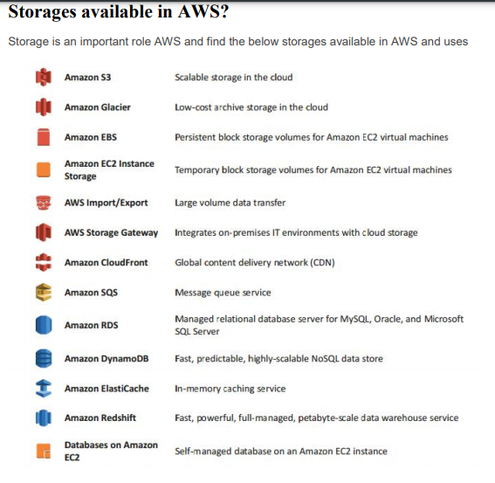

* Data access is provided through the S3 Console.
* Data stored can be either Public or Private based on user requirement.
* Data stored can be encrypted.
* We can define life-cycle policies which can help in automation of data transfer, retention and deletion.

**Lab1:**

1. Create an S3 bucket.
2. Upload an object to S3 Bucket.
3. Access the object on the browser.
4. Change S3 object permissions.
5. Setup the bucket policy and permission and test the object accessibility.

bucket policy into the **Bucket policy editor** , to make all objects publically.

arn:aws:s3:::testbuket121

{

"Version": "2012-10-17",

"Id": "Policy1",

"Statement": [

{

"Sid": "Stmt1",

"Effect": "Allow",

"Principal": "*",

"Action": "s3:GetObject",

"Resource": "**arn:aws:s3:::testbuket121**/*"

}

]

}

**Lab2:**

{

**"Id"**:"Policy1",

**"Version"**:"2012-10-17",

**"Statement"**:[

      {

**"Sid"**:"Stmt1",

**"Action"**:[

            "s3:GetObject"

         ],

**"Effect"**:"Allow",

**"Resource"**:"**replace-this-string-from-your-bucket-arn**/*",

**"Principal"**:"*"

      }

   ]

}

**Link to install aws cli:**

<https://docs.aws.amazon.com/cli/latest/userguide/install-cliv2-linux.html#cliv2-linux-upgrade>